**Ministry of Science and Higher Education**

**of the Russian Federation**

**ITMO University**

Faculty of Digital Transformations

Educational program 01.04.02 Applied mathematics and informatics____

Subject area (major) Big Data and Machine Learning____

REPORT

on practical training Research Internship

Task topic: Investigation of the influence of environmental factors on the psychoemotional state of a person

Student: Yamoldin Alexander, J4134c

Head of Practice from the trainee’s host organization: Basov Oleg, National Center for Cognitive Development, Senior Researcherhead of the laboratory «Center Information Optical Technologies»

Head of Practice from ITMO University: Alexandra Klimova, Faculty of Digital Transformation, assistant professor

|  |  |
| --- | --- |
|  | Practice completed with grade ____  Commission member signatures:  ______________ *full name*  (signature)  ______________ *full name*  (signature)  ______________ *full name*  (signature)  Date ________ |

St. Petersburg  
2022

# Annotation

33 pages, 22 pictures, 3 tables, 21 references

MACHINE LEARNING, CONVOLUTIONAL NEURONNET, OBJECT DETECTION, INDOOR AIR QUALITY, PSYCHO-EMOTIONAL STATE, WELL-BEING

**Object of research**: People psycho-emotional state depends on Indoor Air Quality.

**Target of research:** The aim of the work is to determine the existence of a correlation between the psycho-emotional state of a person and the IAQ index.

**Methodology:** Application of Machine Learning and Artificial Intelligence for Dynamic Carbon Dioxide Level and Indoor Temperature Prediction.

**Results:** In this work have reviewed the theoretical aspects of solving the problems of object detection, selected a model for further study, converted the sensor data to the IAQ index, collected experimental data, selected behavioral markers, selected tools for data markup, and performed initial manual markup of the data

Table of contents

Annotation 1

1. The theoretical part of the computer vision concept 3

1.1 Brief part of detection models 3

1.2 YOLO model 5

2. Installation and configuring YOLOv4 on Darknet Framework in local PC 7

2.1 Git installation 7

2.2 CMake installation 14

2.3 Microsoft Visual Studio installation 18

2.4 CUDA installation 20

2.5 cuDNN installation 23

2.6 OpenCV installation 24

2.7 Darknet Framework installation 28

References 29

# The theoretical part of the computer vision concept

## Brief part of detection models

Object detection models are currently being tested on the Microsoft COCO dataset [1]. This dataset contains 328,000 images with 2.5 million labeled instances of 91 object types that would be easily recognizable by a 4 year old. As of 2022, the best way to detect image objects is to YOLOR [2] and Scaled-YOLOv4 [3] (pic.1).

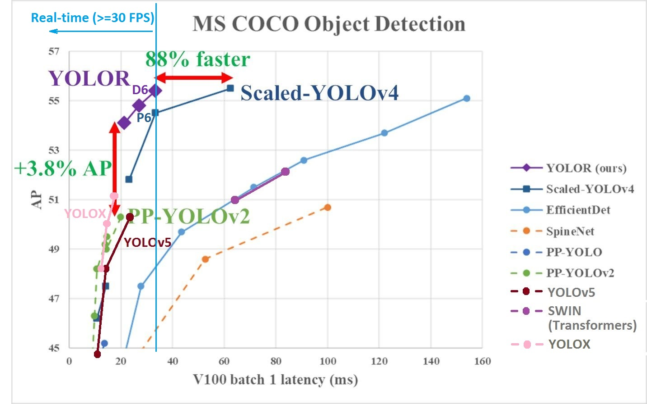

Picture 1 – Models comparing on MS COCO dataset [2]

This paper will consider the world’s best solutions available at the time of writing. Based on the work of [4], it is obvious that the best choice for the problem we are solving is Scaled-YOLOv4 (pic.2).

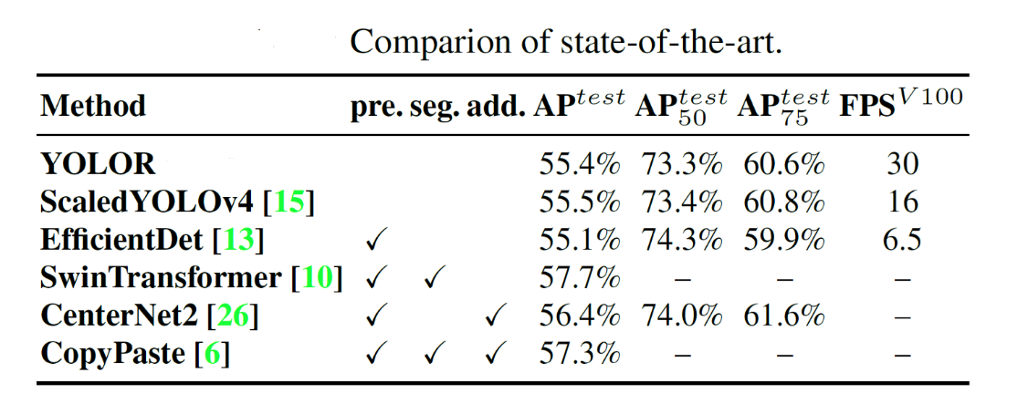

Picture 2 – Comparison state-of-the-art object detection models

ScaledYOLOv4 loses in FPS, but has the highest recognition accuracy. Since this work analyzes the change of IAQ in the room, which is a highly inertial parameter, we do not need to require the neural network to work directly in real time. Therefore, I gave priority to the quality of object recognition.

## YOLO model

The YOLO (You Only Look Once) model was first published (by Joseph Redmon et al.) in 2015. The original YOLO network uses a modified GoogLeNet as a reference network [4]. Later, a new model called DarkNet-19 was created, which follows the general design of 3 × 3 filters, doubling the number of channels at each merging step. The 1 × 1 filters are also used to periodically compress the representation of an object across the network. YOLOv4 is made on the basis of YOLOv3 with the following changes: YOLOv4 uses CSPDarknet53 convolutional neural network as the backbone, SPP (spatial pyramid pooling) intermediate stage (neck) and (PAN) Path Aggregation Network, YOLOv3 full link final classifier (Dense Prediction). The basic models (Backbone) were pre-trained as image classifiers before being adapted to the detection task. To adapt the classification network into a network for object detection, it is necessary to remove the last few layers of the network and add a convolution layer with filters to produce Bbox predictions. A grid is superimposed on the input image, dividing it into S×S regions. For each region, the neural network determines 5 bounding boxes for the object, a confidence score for frame detection, which reflects the degree of confidence of the model that the field contains an object:

|  |  |
| --- | --- |
| $$confidence=\operatorname{Pr}\left(object\right)*IOU(b, object)$$ | (1) |

As a result, the network selects the area with the highest level of network response reliability.

Unlike the parent YOLOv4 (pic.3) model the Scaled-YOLOv4 authors apply the concepts laid out in the Cross-Stage Partial Networks [5].

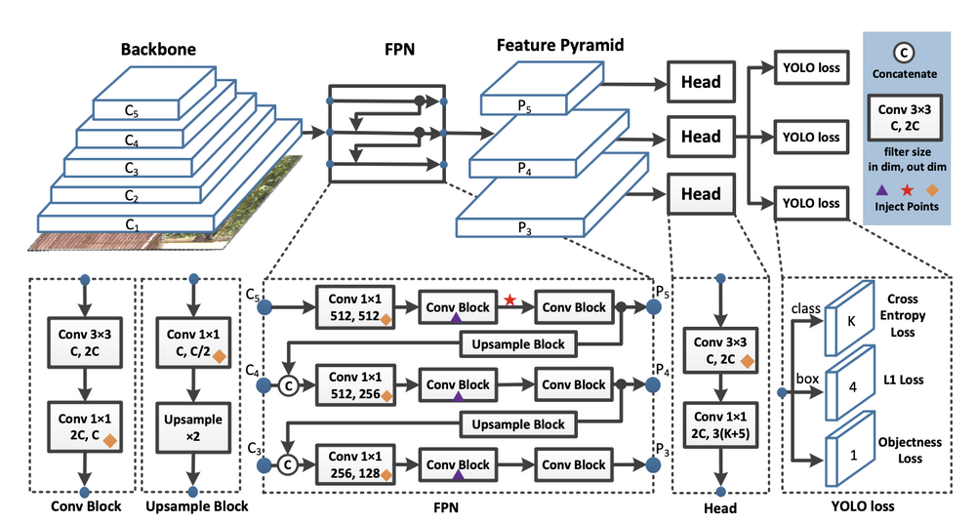

Picture 3 – YOLOv4 architecture

To detect large objects in large images, the authors increase the depth and number of stages in in the CNN backbone and neck. This allows them to first scale up input size and number of stages, and dynamically adjust width and depth according to realtime inference speed requirements.

However, a special difficulty is the installation and configuration of this architecture on Windows 10. The installation and configuration of the YOLOv4 neural network on a personal computer under Microsoft Windows 10 was performed during the technological practice.

# Installation and configuring YOLOv4 on Darknet Framework in local PC

## 2.1 Git installation

The first thing you need to install on your personal computer is git. It is necessary to download the executable file [6] in our case for the 64-bit operating system.

After downloading the file, run the executable file and follow the instructions.

The first window you will see is the welcome screen (pic.4) and click *Next*

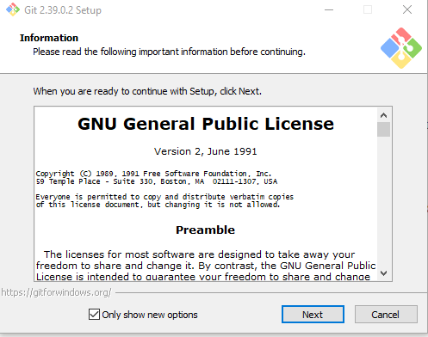

Picture 4 – Git welcome screen

On the next window (pic.5) keep the default values and click *Next*

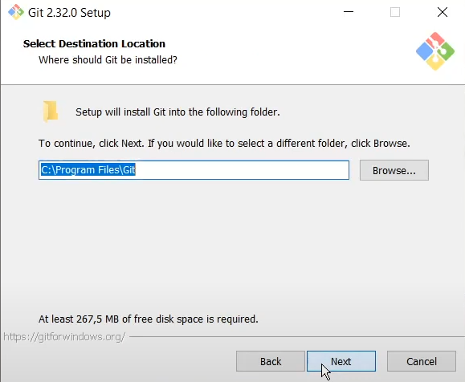

Picture 5 – The window for selecting the git installation path

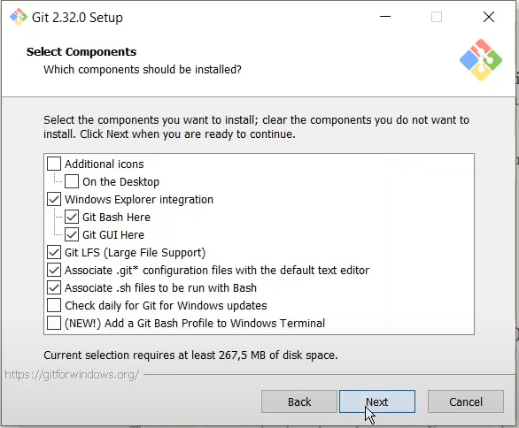

Picture 6 – Selecting components

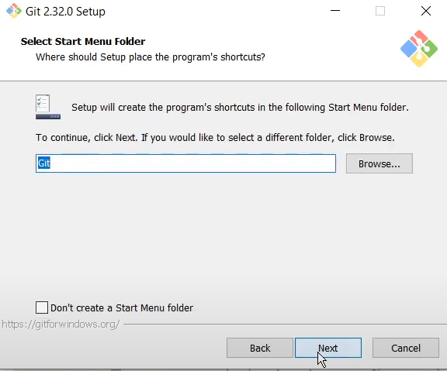

Picture 7 – Selecting start menu folder

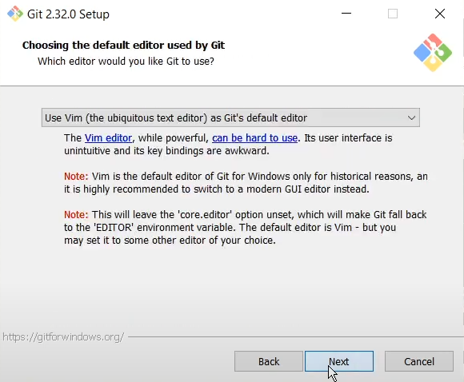

Picture 8 – Selecting default editor

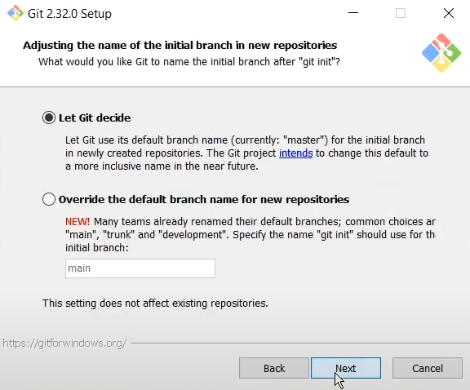

Picture 9 – Adjusting the name of the initial branch in new repositories

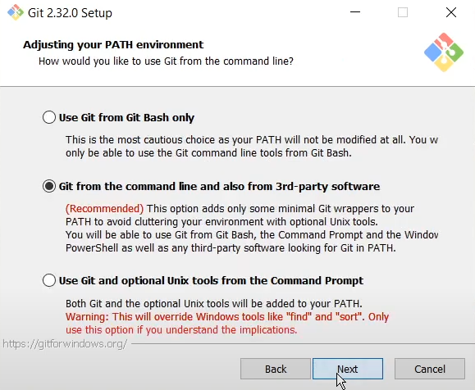

Picture 10 – Adjusting PATH environment

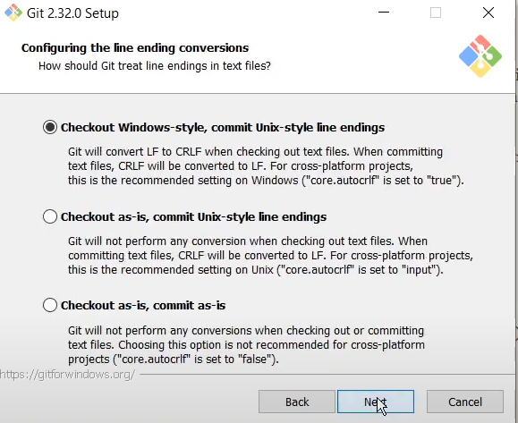

Picture 11 – Configuring the line ending conversions

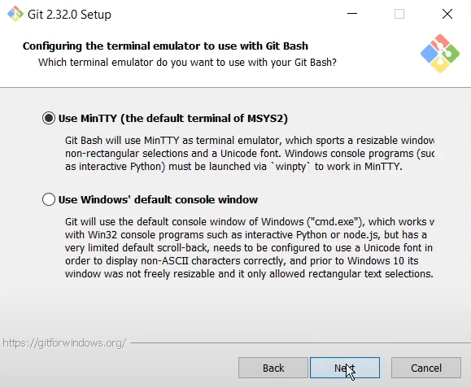

Picture 12 – Configuring the terminal emulator

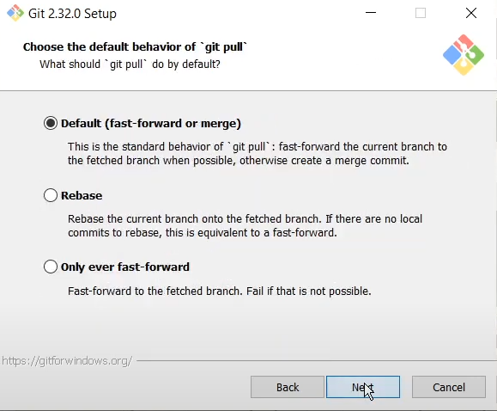

Picture 13 – Choose the default behavior of Git Pull

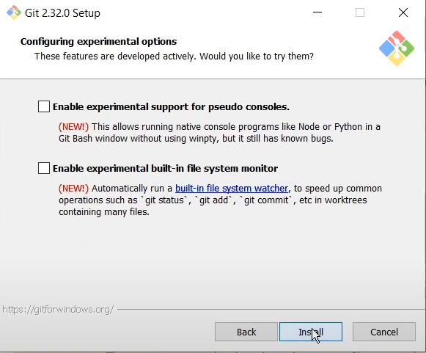

Picture 14 – Configuring experimental options

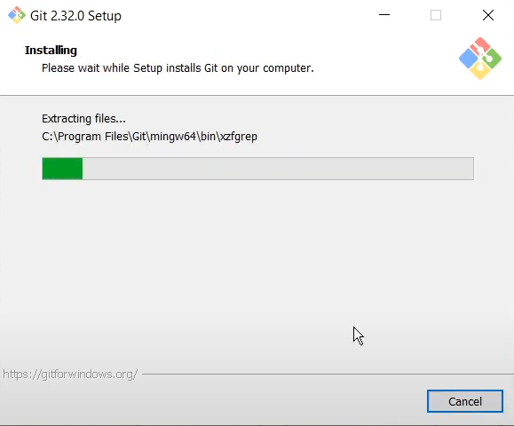

Picture 15 – Install git

Picture 17 – Installation success

## 2.2 CMake installation

It is necessary to download the cmake-3.21.0-rc2-windows-x86_64.msi package [7] in our case for the 64-bit operating system.

After downloading the file, run the .msi package and follow the instructions.

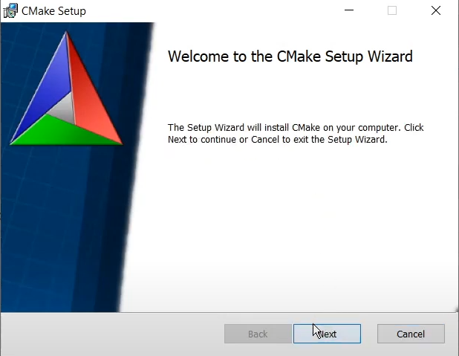

Picture 18 – CMake setup

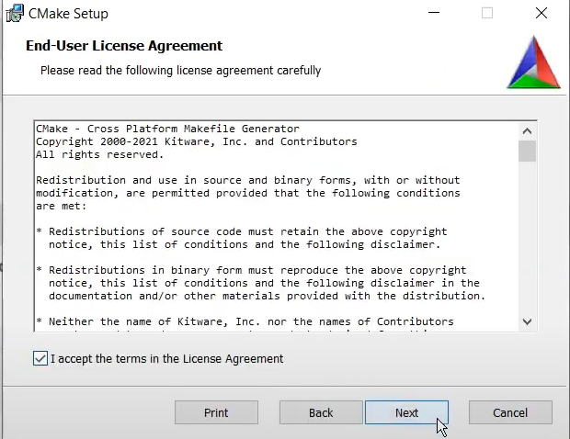

Picture 19 – License Agreement

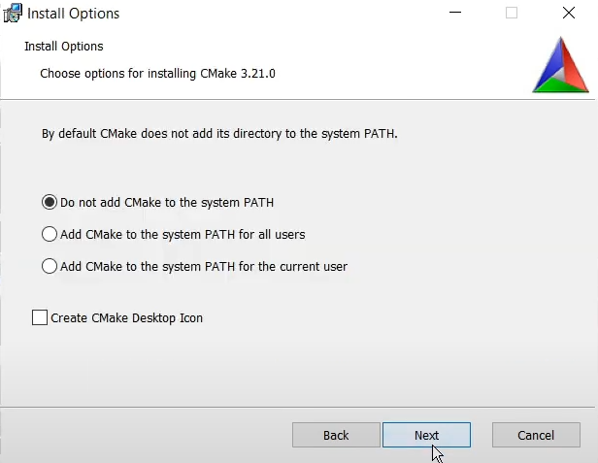

Picture 20 – Install options

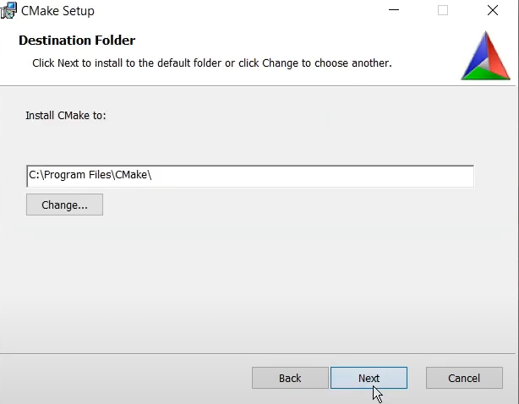

Picture 20 – Destination Folder

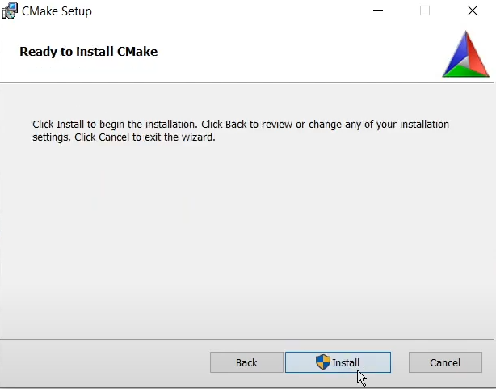

Picture 21 – Ready to install

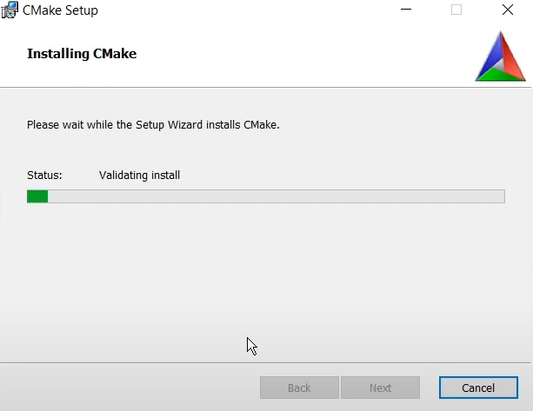

Picture 22 – Installing CMake

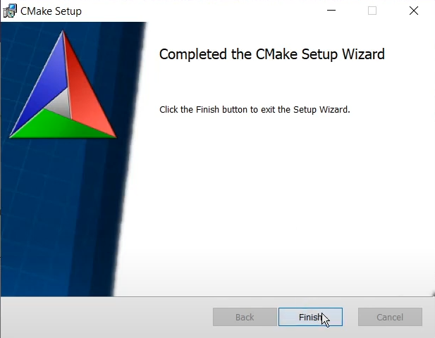

Picture 23 – Installation CMake succesfull

## 2.3 Microsoft Visual Studio installation

It is necessary to download the Microsoft Visual Studio execution file [8] in our case for the 64-bit operating system.

After downloading the file, run the execution file and follow the instructions.

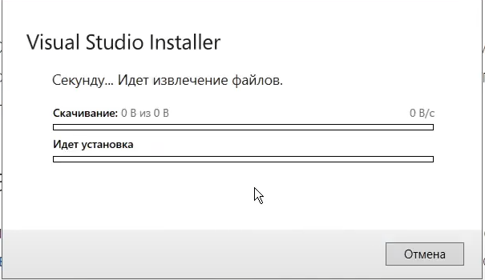

Picture 24 – Wait for file extraction

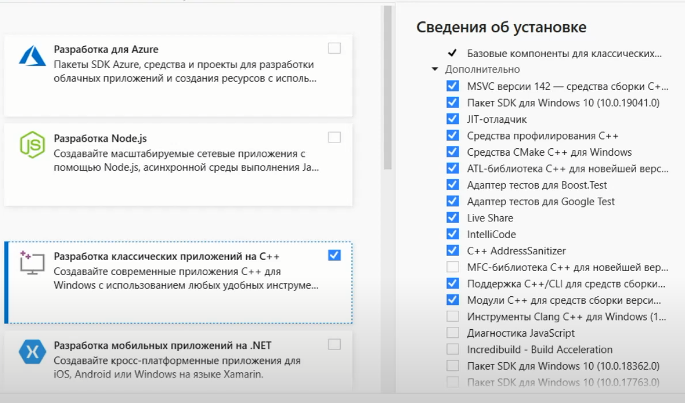

Picture 25 – Choose the following modules for C++

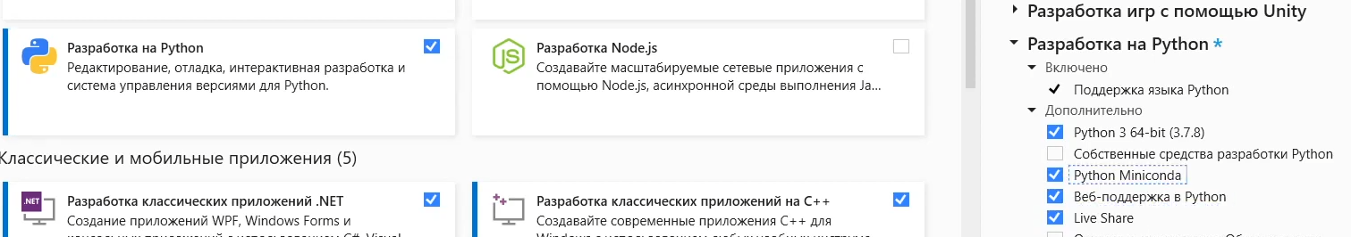

Picture 26 – Choose the following modules for python

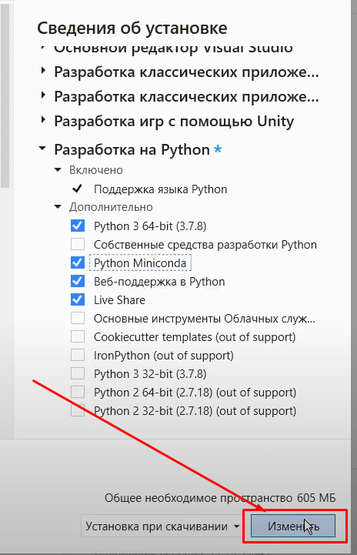

Picture 27 – Click to the button in right down corner

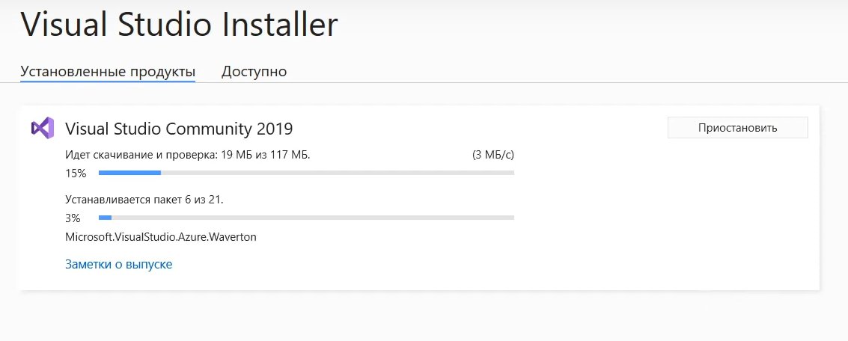

Picture 28 – Redirecting to the installing process

Picture 29 – Installing process end successful

## 2.4 CUDA installation

It is necessary to download the CUDA Toolkit execution file [9] in our case for the 64-bit operating system.

After downloading the file, run the execution file and follow the instructions.

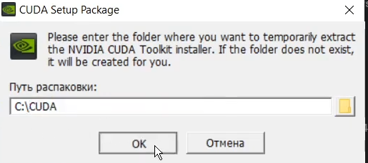

Picture 30 – Path to CUDA

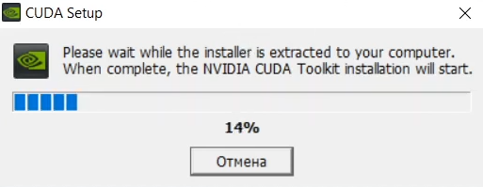

Picture 31 – CUDA extraction

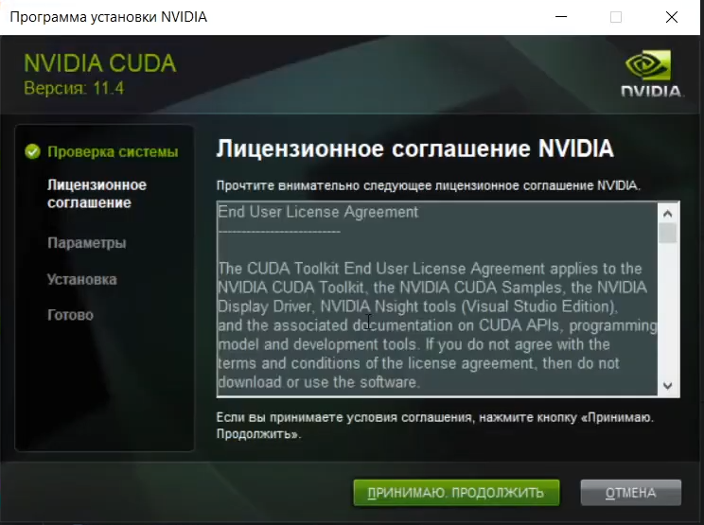

Picture 32 – CUDA license agreement

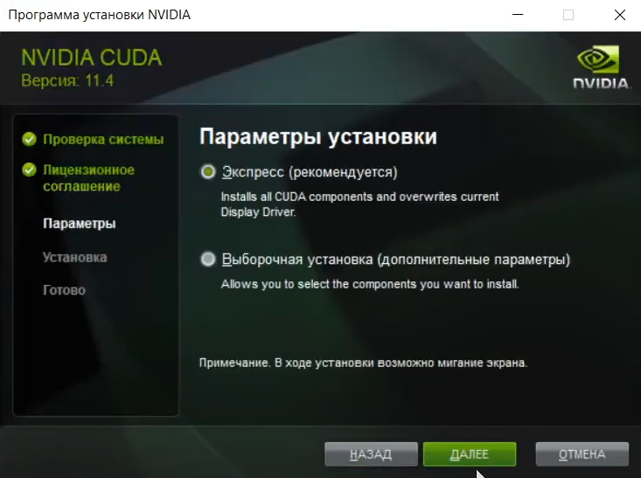

Picture 33 – CUDA parameters installation

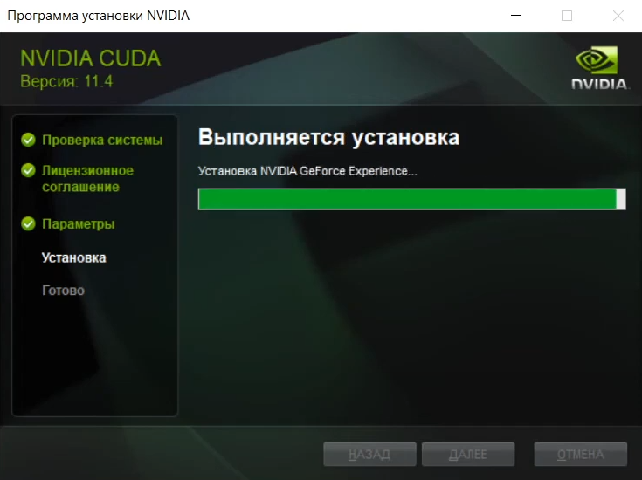

Picture 34 – CUDA installation

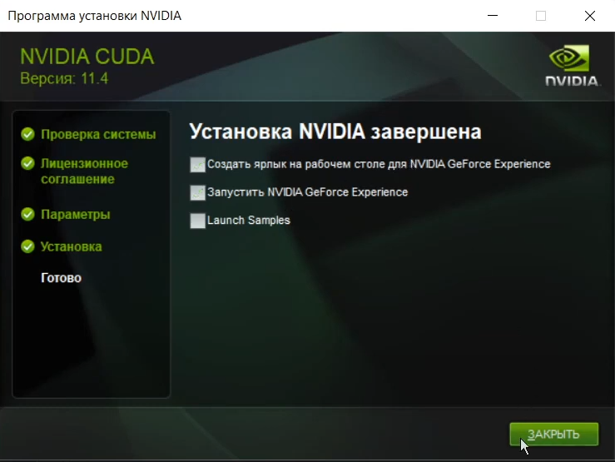

Picture 35 – CUDA installation completed

## 2.5 cuDNN installation

Pay attention! You must be a registered user in developer.nvidia.com community. It is necessary to download the cuDNN 11.x archive [10] in our case for the 64-bit operating system.

After downloading the file, unpackage the cuDNN archive to C:\cuda and follow the instructions.

Copy all files from

C:\cuda\bin and past them in C:\Program Files\NVIDIA GPU Computing Toolkit\CUDA\v11.4\bin

The same way copy files from C:\cuda\include and past them in C:\Program Files\NVIDIA GPU Computing Toolkit\CUDA\v11.4\include

The same way copy files from C:\cuda\lib\x64 and past them in C:\Program Files\NVIDIA GPU Computing Toolkit\CUDA\v11.4\lib\x64

## 2.6 OpenCV installation

It is necessary to download the OpenCV source code archive [11] in our case for the 64-bit operating system.

Create directory named “opencv” on path C:\opencv and in the new directory create another one directory C:\opencv\build

After downloading the file, unpackage OpenCV-4.5.1.zip archive in C:\opencv.

Also, it is necessary to download the open_contrib source code archive [12].

After downloading the file, unpackage opencv_contrib-4.5.1.zip archive in C:\opencv.

Now we should build OpenCV with CMake. Start CMake application and follow the instructions.

Browse for the source code in C:\opencv\opencv-4.5.1 and build in C:\opencv\build. Stay checkbox to Grouped and click Configure

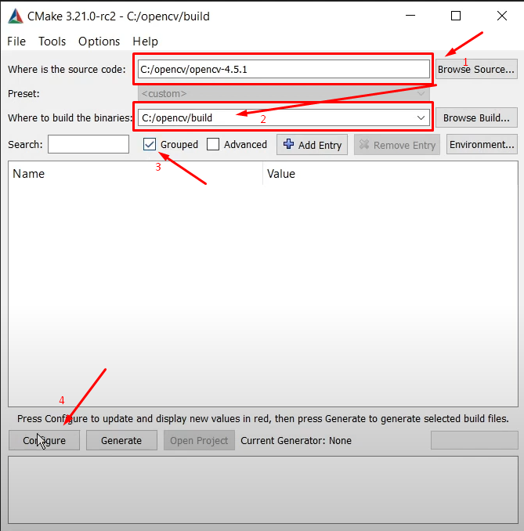

Picture 36 – Configuration build OpenCV

Choose configuration as on the pic.37 and click Finish.

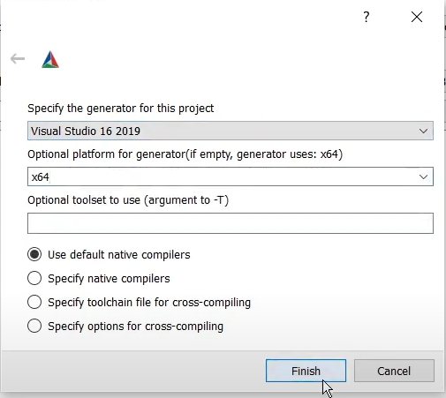

Picture 37 – Finish project configuration

Wait while OpenCV configurating. When configurating done, you must go to BUILD (pic.38)

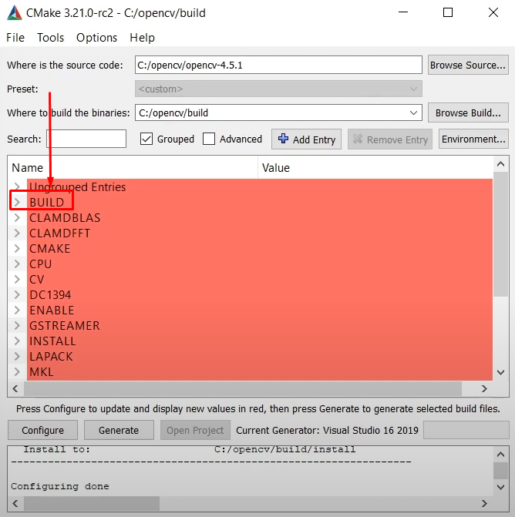

Picture 38 – Go to BUILD after configurating

And stay checkbox BUILD_opencv_world as in pic.39. and click to the Generate button in the down of window.

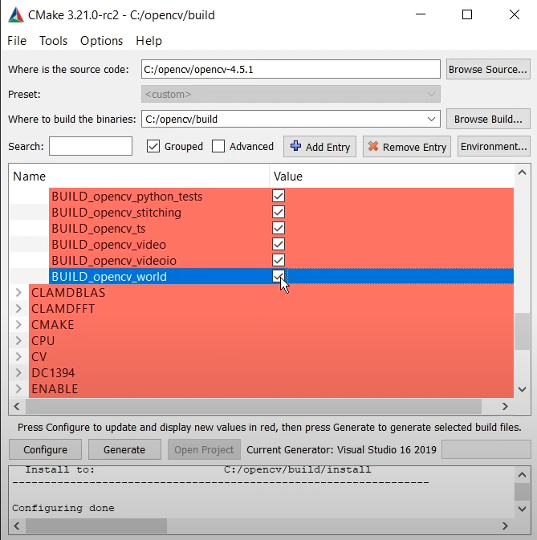

Picture 39 – Add BUILD_opencv_world checkbox

When build of OpenCV is finished you must open with Microsoft Visual Studio file C:\opencv\build\ALL_BUILD.vcxproj

In the Microsoft Visual Studio (pic. 40) choose Release (step 1), go to CMakeTargets, choose ALL_BUILD, do mouse right button click and choose Build.

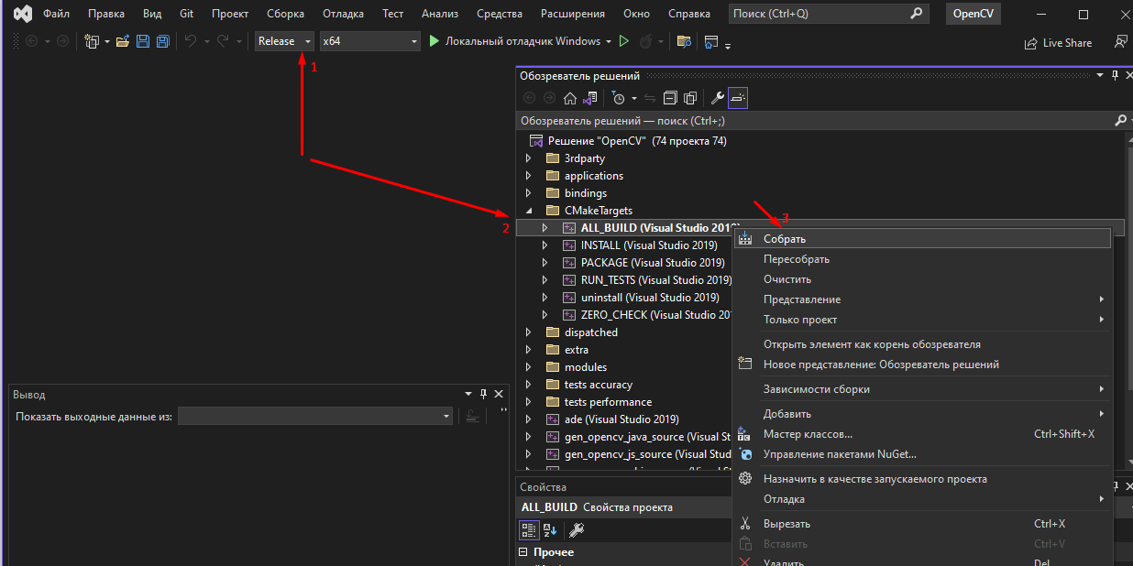

Picture 40 – Build ALL_BUILD

When build is done, you should choose INSTALL, do mouse right button click and choose Build (pic.41).

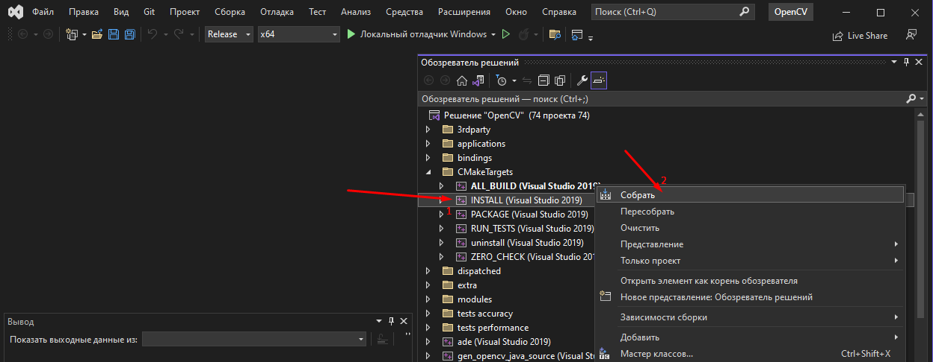

Picture 41 – Build INSTALL

Now, OpenCV is successfully installed.

## 2.7 Darknet Framework installation

# References

1. Lin T.-Y. et al. Microsoft COCO: Common Objects in Context // Computer Vision – ECCV 2014. Cham: Springer International Publishing, 2014. P. 740–755.
2. Wang C.-Y., Yeh I.-H., Liao H.-Y.M. You Only Learn One Representation: Unified Network for Multiple Tasks [Electronic resource] // arXiv.org. 2021. URL: https://arxiv.org/abs/2105.04206.
3. Wang C.-Y., Bochkovskiy A., Liao H.-Y.M. Scaled-YOLOv4: Scaling Cross Stage Partial Network [Electronic resource] // arXiv.org. 2020. URL: https://arxiv.org/abs/2011.08036.
4. Redmon J. et al. You Only Look Once: Unified, Real-Time Object Detection [Electronic resource] // arXiv.org. 2015. URL: https://arxiv.org/abs/1506.02640.
5. Wang C.-Y. et al. CSPNet: A New Backbone that can Enhance Learning Capability of CNN [Electronic resource] // arXiv.org. 2019. URL: https://arxiv.org/abs/1911.11929.
6. <https://github.com/git-for-windows/git/releases/download/v2.39.0.windows.2/Git-2.39.0.2-64-bit.exe>
7. <https://cmake.org/files/v3.21/cmake-3.21.0-rc2-windows-x86_64.msi>
8. <https://visualstudio.microsoft.com/ru/thank-you-downloading-visual-studio/?sku=Community&channel=Release&version=VS2022&source=VSLandingPage&cid=2030&passive=false>
9. <https://developer.download.nvidia.com/compute/cuda/11.4.0/local_installers/cuda_11.4.0_471.11_win10.exe>
10. <https://developer.nvidia.com/downloads/c118-cudnn-windows-8664-87084cuda11-archivezip>
11. <https://github.com/opencv/opencv/archive/4.5.1.zip>
12. <https://github.com/opencv/opencv_contrib/archive/refs/tags/4.5.1.zip>